Medical Center or Facility Name

MY HEALTHeVET

Registration and IPA Information
- Many Co-Managed patients have found that the VA’s My HealtheVet service has been beneficial in helping them manage information between their different providers.
- The information on this handout will help the patient*
  - Register for a My HealtheVet account
  - Obtain an upgraded account through In Person Authentication (IPA) which allows access to personal health information, including recent progress notes, medication lists, laboratory results, and clinic appointments.
*Note that this portal is for patient login only. At this time there is no mechanism by which providers can login on behalf of their patients. However, providers can access more information about
My HealtheVet features like Blue Button at www.va.gov/bluebutton and information about the VA CCD (Care Coordination Document) at http://www.va.gov/BLUEBUTTON/Resources.asp.
1) Register for a My HealtheVet account - Registration is quick and easy. Open your internet program and in the address bar type www.myhealth.va.gov. Then choose the Register Today button to start the registration process.
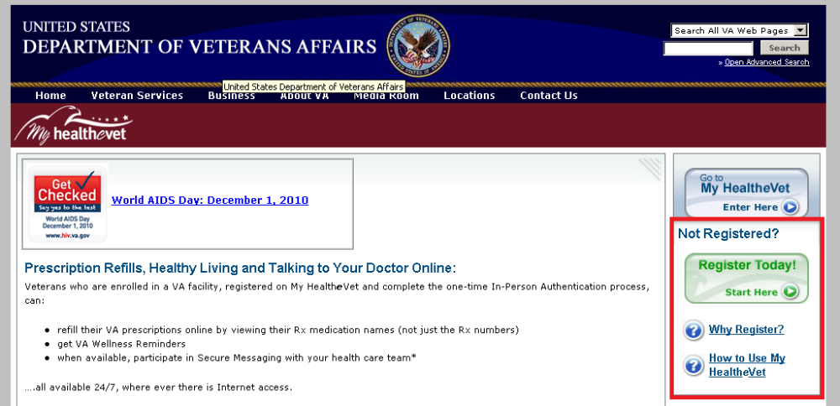
- When you register, enter your First Name, Last Name, Date of Birth, Gender and Social Security Number. If you use the VA health care system, it is important that this information match your VA electronic health record information. TIPS: 1) Use your Veterans Identification Card (VIC) to match your information. 2) Anything with a red asterisk * needs to be completed during the registration process, for example, your address and creating a user id and password.
- If you use the VA health care system, make sure you select the “VA Patient” checkbox when you register. This is a required step before you can get an upgraded account.* You will have access to medication names in VA Prescription Refill, Wellness Reminders, and be able to use Secure Messaging when it is available in your area with an upgraded account. You may receive electronic copies of portions of your VA health information with an upgraded account.
To check your account:
  - Login to My HealtheVet
  - Select the PERSONAL INFORMATION tab
  - Select the Profiles sub-tab
  - Under Relationship to the VA, if you use the VA health care system, make sure you select the “VA Patient” checkbox (see red box below)
    - If “VA Patient” is not checked, and you use the VA health care system, select this box
    - This will put a checkmark in the box
  - Select the Save button at the bottom of the screen
*Note: You have an upgraded account when you have been In-Person Authenticated.
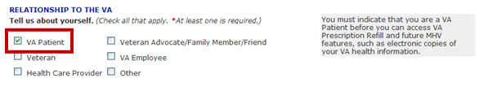

2) Upgraded Account (In-Person Authenticated)- My HealtheVet created a way to prove a Veteran user’s identity. The process is called In-Person Authentication. When you complete this process, you have an upgraded account. My HealtheVet users who are VA patients and have an upgraded account may be able to view, print and download parts of their VA electronic health record, such as your medication list, appointments and lab results. In fact, you will be able to access all of the following personal health data (via the blue button) when you have an upgraded account:
- VA Demographics
- VA Problem List (active problems) -7 days after entry*
- VA Admissions and Discharges (including Discharge Summaries- 7 days after completion)*
- VA Notes (Progress Notes) - All completed Progress Notes from January 1, 2013 forward - 7 days after note completed*
- VA Laboratory Results- 7 days after test results verified*
- VA Vitals and Readings
- VA Pathology Reports: (Surgical Pathology, Cytology, Electron Microscopy) 14 days after report completed
- VA Radiology Reports - 7 days after report verified
- VA Electrocardiogram (EKG) Reports (list of studies)
- VA CCD (Care Coordination Document)
*Information on the “hold” period mentioned in several of these options can be found here: http://vaww.va.gov/MYHEALTHEVET/docs/blue_button/VA_Blue_Button_VA_OpenNotes_Q_A.PDF
Several requirements must be met before In-Person Authentication can occur:
- Be registered as a "VA Patient" in their My HealtheVet account
- View the My HealtheVet Orientation Video (available online or at local VA facility)
- Read and sign VA Form, 10-5345a-MHV (available online or at local VA facility)
To have your identity verified:
- Present a government issued photo identification (Veterans Identification Card (VIC) or driver’s license is acceptable) to a qualified VA staff member.
IMPORTANT: Please note that any information entered in your My HealtheVet account is for you only and is not shared with your VA facility. If you need to update the information in your official VA record, including the mailing address for your VA prescriptions, please contact the appropriate office at your local VA facility.

General Information about MHV
- If you use the VA Health Care System and want to see parts of your VA electronic health record, you must complete In-Person Authentication.
- To use the Blue Button, you need a computer with a browser and Internet access. Some people have Internet access in their home. Public libraries and Internet cafés also provide Internet access. If you want to download your health information using a public computer, consider saving your information to a CD or thumb drive. You need to have access to a printer connected to the computer if you want to print your health information.

- You are the only one who sees your health information in My HealtheVet. You choose with whom to share your information. If you want someone else to see your health information, you must give it to that person.

You are responsible for protecting the personal health information you print out or download. It is important to protect your information. Protect this information the same way you would protect your banking or credit card information. Do not leave your printed information in a printer. Do not save your downloaded information to a public computer. When using a public computer, save your health information to a CD or a thumb drive. Remember to take the CD or thumb drive with you when you finish.

