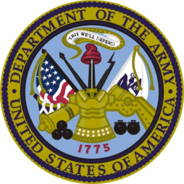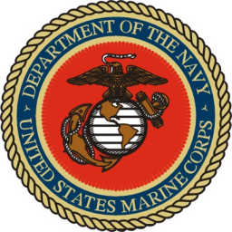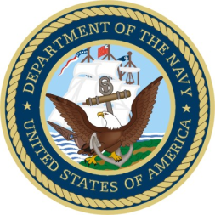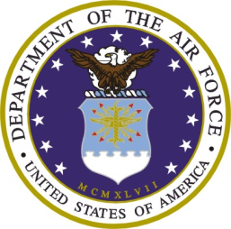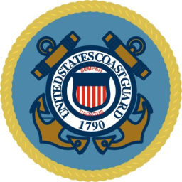
Federal Benefits and Local Community Resources for Veterans and Their Families
Sponsored by the
Grant County Commission Veterans Advisory Board and
U.S. Department of Veterans Affairs, Veterans Health Administration, Office of Rural Health

Date: Saturday, October 1, 2011
Time: 10 am to 2 pm
Flag ceremony 10:00
Location: Grant County Fairgrounds, (Commercial Building)

Come with your questions about your VA Benefits.
Representatives will be on site to support you with information and application for services through local, State and Federal agencies.
Spouses, families and loved ones of Veterans are encouraged to attend!

- VA Healthcare
- Claims Assistance
- Veterans Service Organizations
- Elderly Care
- Resources and Benefits for Veterans’ Family Members
- Health Screenings
- Education Assistance
- Food Vendors
- Specialty Programs
- Employment Agencies Looking to Hire Veterans
- Information and Assistance on Locally Available Resources
- Mortgages and Housing Information
- Low Income Subsidy Programs
- Much More…

Thank you Veterans for your service!

