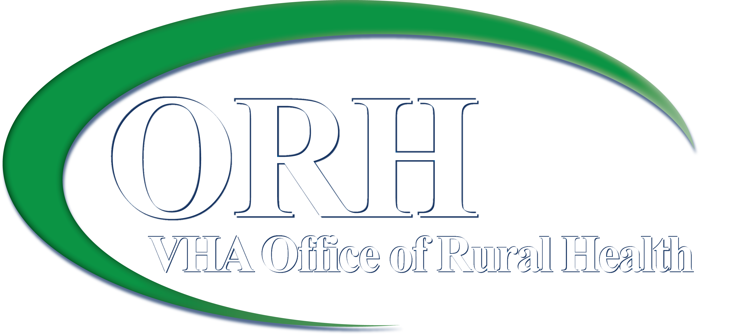

Rural Veteran Outreach Project Training Evaluation
- What parts of this meeting were useful to you?

- What parts of this meeting should we change for future trainings?

- Please provide feedback on the presentation materials and handouts:

- Based on the information provided during this meeting, would you know how to help a Veteran who has questions about his VA benefits? YES NO
If No, please explain:

- If NO to # 4, Do you know who you can refer the Veteran to for assistance? YES NO

Please select which Veteran issues that you would like more information about in the future:

- Aid and Attendance
- Benefits for survivors and dependants
- Burial benefits
- Disability Compensation
- Educational assistance
- Eligibility/enrollment
- Health care benefits
- Health care for survivors and dependants
- Long term care benefits
- Low income pensions
- Mental health issues
- Military sexual trauma
- Post-deployment transition assistance
- Programs for homebound Veterans
- Programs for homeless Veterans
- Programs for incarcerated Veterans
- Specially adapted housing
- Substance abuse programs
- Telehealth
- Traumatic brain injury
- Travel reimbursement
- VA life insurance
- VA mortgages
- Vocational rehabilitation/job retraining

Other:

Please write your name and email if you would like someone to contact you about these topics.

